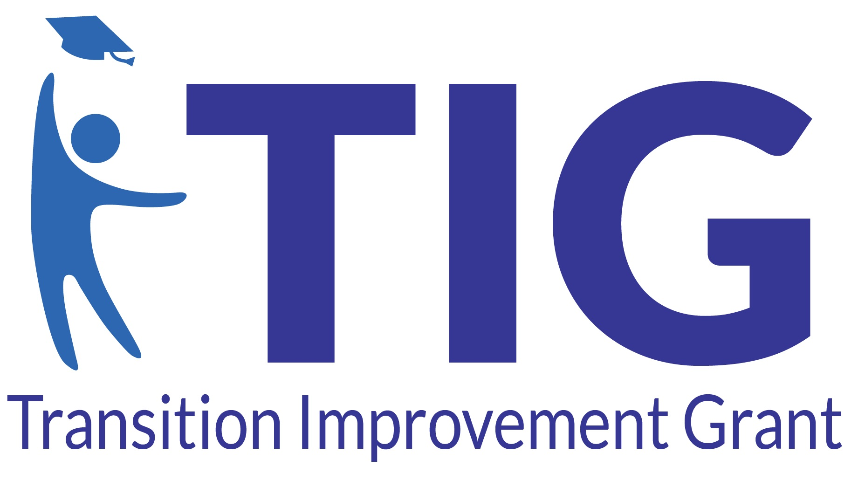
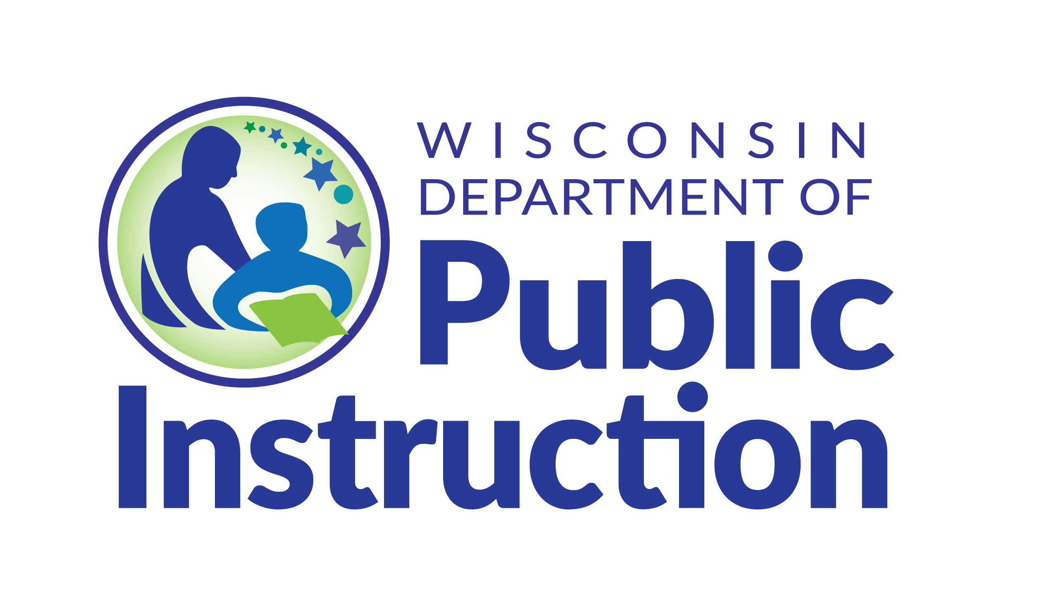

Strengthening Alignment Across Systems

Complete the below alignment activity with the CCoT Team to explore how the team connects with youth and families, local partners, and statewide transition partners. Identify where alignment is strong and opportunities to strengthen connections.
Connection Level | What is Working Well | Where Could We Strengthen Alignment?
Youth/Family - CCoT | [Type what's working] | [Type areas to strengthen]
CCoT - WiCoT (Statewide) | [Type what's working] | [Type areas to strengthen]
CCoT - Community Partners | [Type what's working] | [Type areas to strengthen]
System Alignment Questions
How does our CCoT Team learn about statewide resources, initiatives, and opportunities?
[Type response here]
How do we share local needs and challenges with statewide partners?
[Type response here]
What is one connection our team would like to make to strengthen our team?
[Type response here]
What is one celebration our team would like to share with our statewide partners?
[Type response here]

The Transition Improvement Grant (TIG) (CFDA# 84.027A) acknowledges the support of the Wisconsin Department of Public Instruction in the development of this material and for the continued support of this federally funded grant program. There are no copyright restrictions on this document; however, please credit the Wisconsin DPI and support of federal funds when copying all or part of this material.

