
County Community on Transition (CCoT) Team Playbook

Welcome to the County Community on Transition (CCoT) Playbook
Supporting successful futures for youth with disabilities is a shared responsibility. No single educator, youth, family member, service system, or community-based organization can do it alone. Successful transition happens when communities work together to create coordinated supports, meaningful opportunities, and clear pathways to adulthood.
The Wisconsin County Community on Transition (CCoT) Playbook was developed by the Transition Improvement Grant (TIG), with guidance from the Wisconsin Community on Transition (WiCoT), to help communities build, strengthen, and sustain effective local transition partnerships.
Whether your community is creating a new CCoT or strengthening an existing one, this playbook provides practical guidance, tools, and resources to help the team:
- Build strong partnerships with schools, agencies, employers, families, youth, and community organizations
- Develop a shared vision, purpose, and mission
- Use data to identify community strengths and priorities
- Create and implement meaningful action plans
- Measure progress and continuous improvement
- Expand opportunities that improve postsecondary outcomes for youth with disabilities
This playbook is more than a collection of resources; it’s a guide for building collaborative communities that work together to improve transition outcomes. Throughout these pages, you will find content, takeaways, activities, resources, and examples designed to help the CCoT Team move from ideas to action.
No two communities are exactly alike. Every CCoT brings unique strengths, partnerships, and opportunities. Rather than providing a single roadmap, this playbook offers a flexible framework that CCoTs can adapt to meet their local needs while remaining focused on a common goal: improving outcomes for youth with disabilities.
Together, we can strengthen partnerships, remove barriers, expand opportunities, and build communities where every youth has the support they need to succeed in employment, postsecondary education and training, and independent living in their community.

How to Use the CCoT Team Playbook 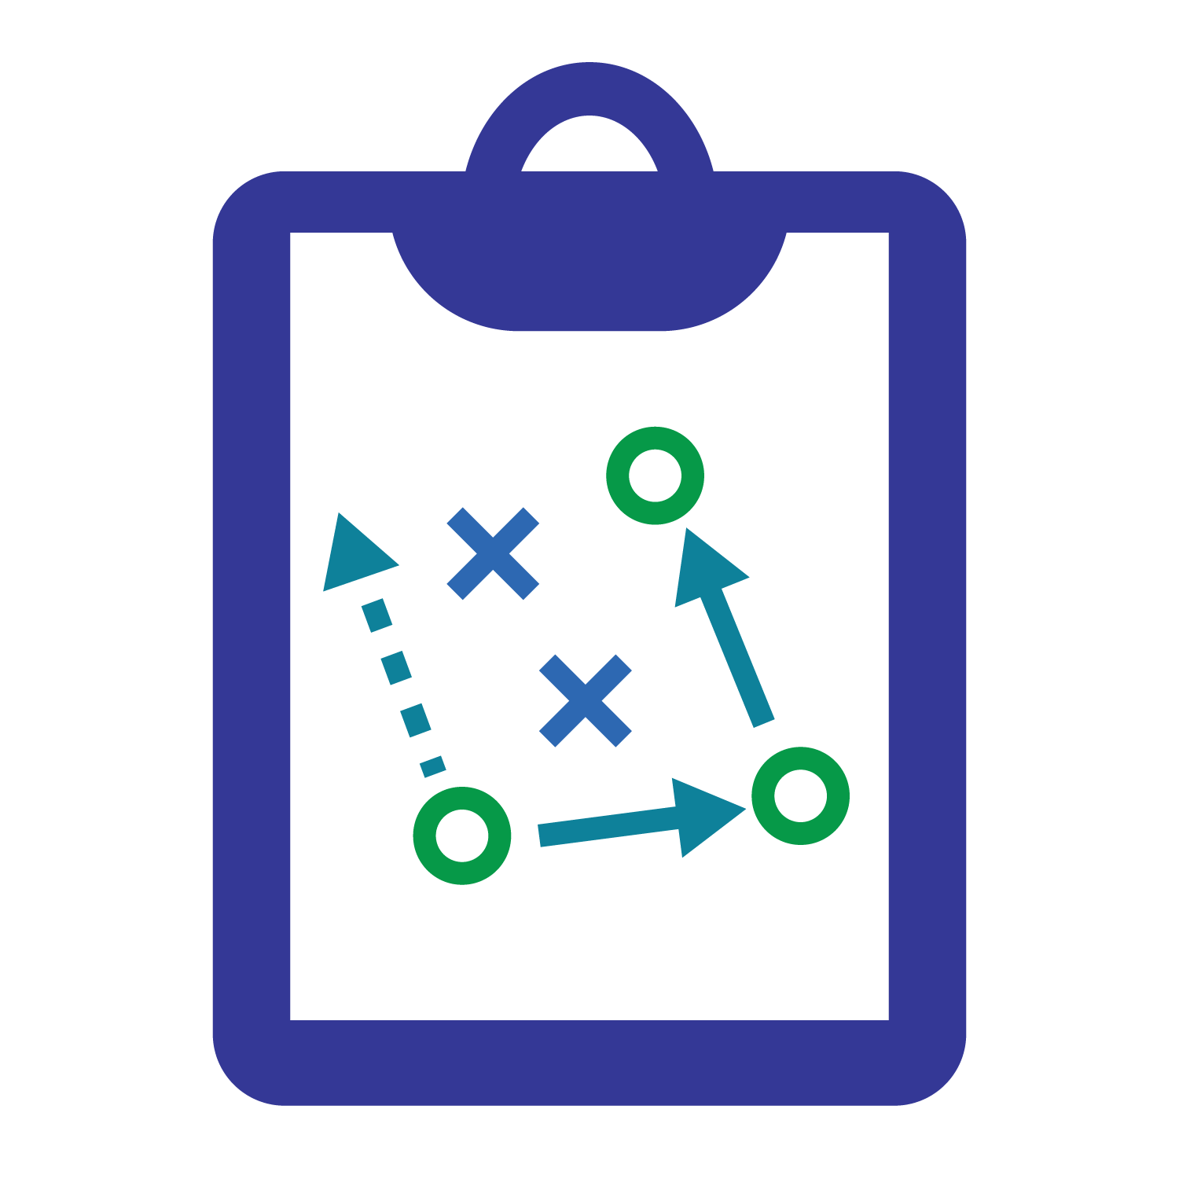
The CCoT Team Playbook is designed to be used with your CCoT Team—not simply read from beginning to end. It provides practical guidance to help teams understand, build, organize, and strengthen their work together.
Each section includes key examples, pause & reflect opportunities, resources, takeaways, and/or activities to help teams put ideas into practice. The sections are designed to build upon one another, but the Playbook is also a resource teams can return to whenever they need guidance, ideas, or tools to support their work.
Think of the Playbook as a road map for the CCoT Team. You may move through the sections in order as your team builds its foundation, or return to a specific section when a question or need arises. Each team should choose their own path. For example:
- If you are a new team – Start with Building the Foundation.
- If the team is established, but needs to strengthen participation – Go to Leading Effective Teams.
- If the team is ready to identify priorities – Go to Using Data and Planning for Action.

The CCoT Playbook at a Glance
The Playbook begins with a Welcome and How to Use the Playbook section, followed by eight sections that guide CCoT Teams through the process of building and strengthening their work. The resource hub provides links to all of the resources utilized throughout the Playbook.
The overall journey is to:
Understand → Build → Organize → Align → Learn → Act → Sustain → Connect → Continue
Page # | Section | Main Question It Answers
7-14 | Section 1: Understanding the Foundation | Why does community collaboration matter, and where does the CCoT fit within Wisconsin's transition system?
15-23 | Section 2: Building Your CCoT Team | Who needs to be at the table, and how do we build a strong, inclusive team?
24-33 | Section 3: Meeting Structures | How do we organize our time together so the team can build relationships and get meaningful work done?
34-38 | Section 4: Establishing a Shared Direction | Where are we going, why do we exist, and how will we get there?
39-44 | Section 5: Knowing Your Community to Identify Priorities | What is happening in our community, and what should we focus on?
45-53 | Section 6: From Shared Priorities to Collective Action | What will we do about it, and how will we work together to make it happen?
54-59 | Section 7: Sustaining Momentum and Continuous Improvement | How do we keep the work going, growing, and improving?
60-63 | Section 8: Continuing the Journey Together | How do we stay connected, learn from others, and keep moving forward?
64-65 | Resource Hub | All resources provided in the CCoT Playbook

How to Navigate the Playbook
The Playbook focuses on what CCoT Teams need to know to build and strengthen their collaborative work. It provides opportunities to explore, take away information, pause and reflect and see it in action. Throughout the Playbook, the team will see highlighted features to support the team throughout the process. Any team member can lead a section of the Playbook.
Playbook Features
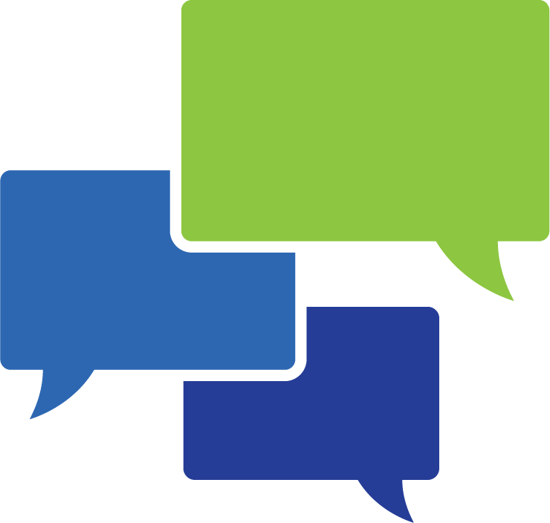 Pause & Reflect - A moment to reflect on the team’s learning, consider what it means for the work, and identify next steps.
Resource Spotlight — A tool, guide, video, or other resource to explore for team use.
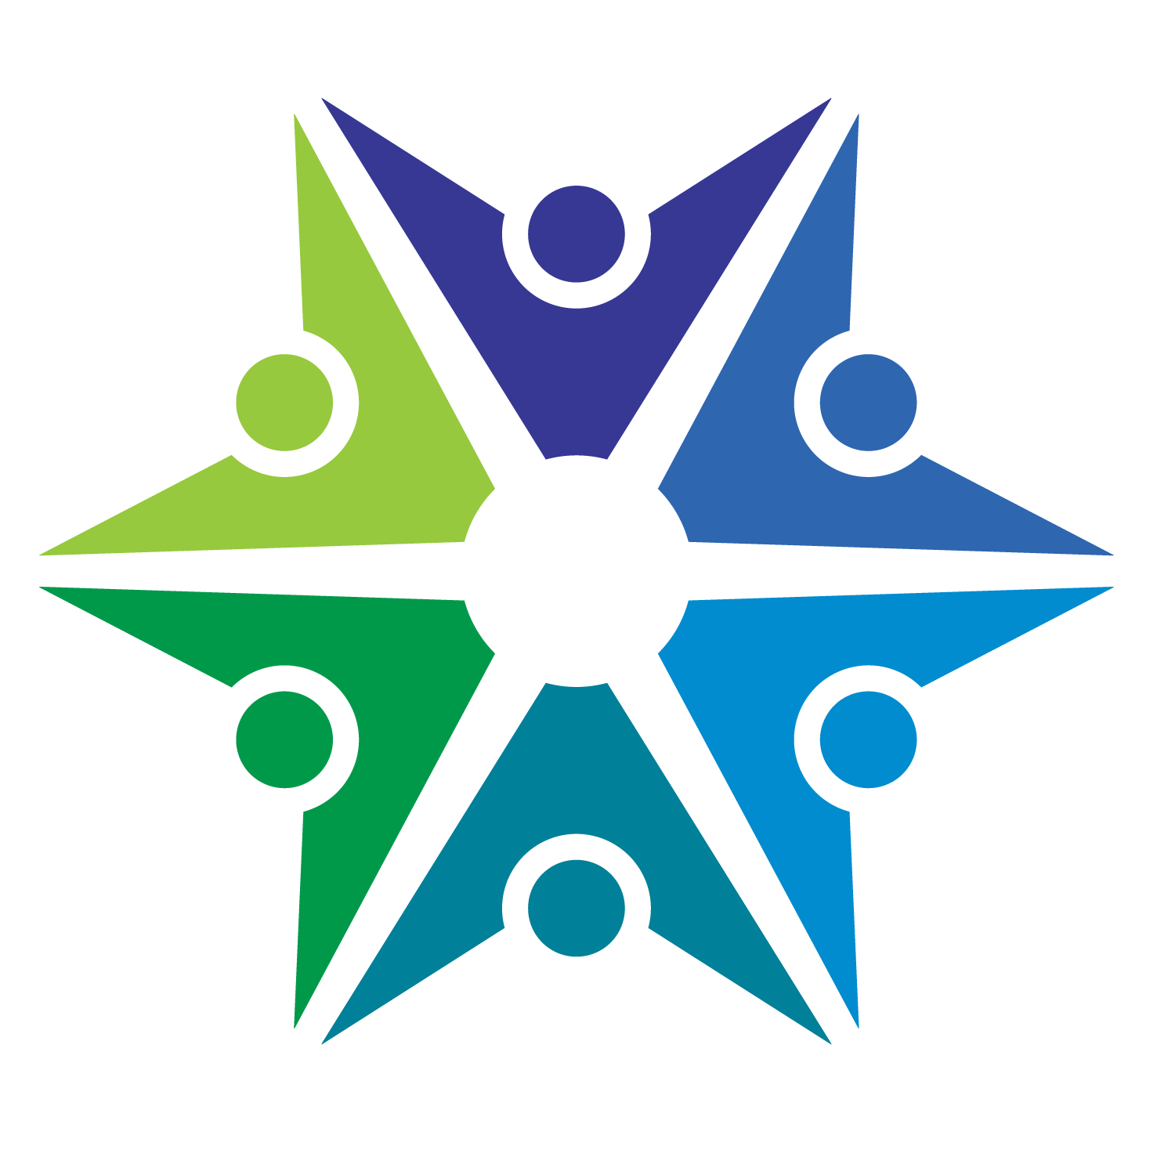 Team Activity — An opportunity to put ideas into practice and work through them together as a team.
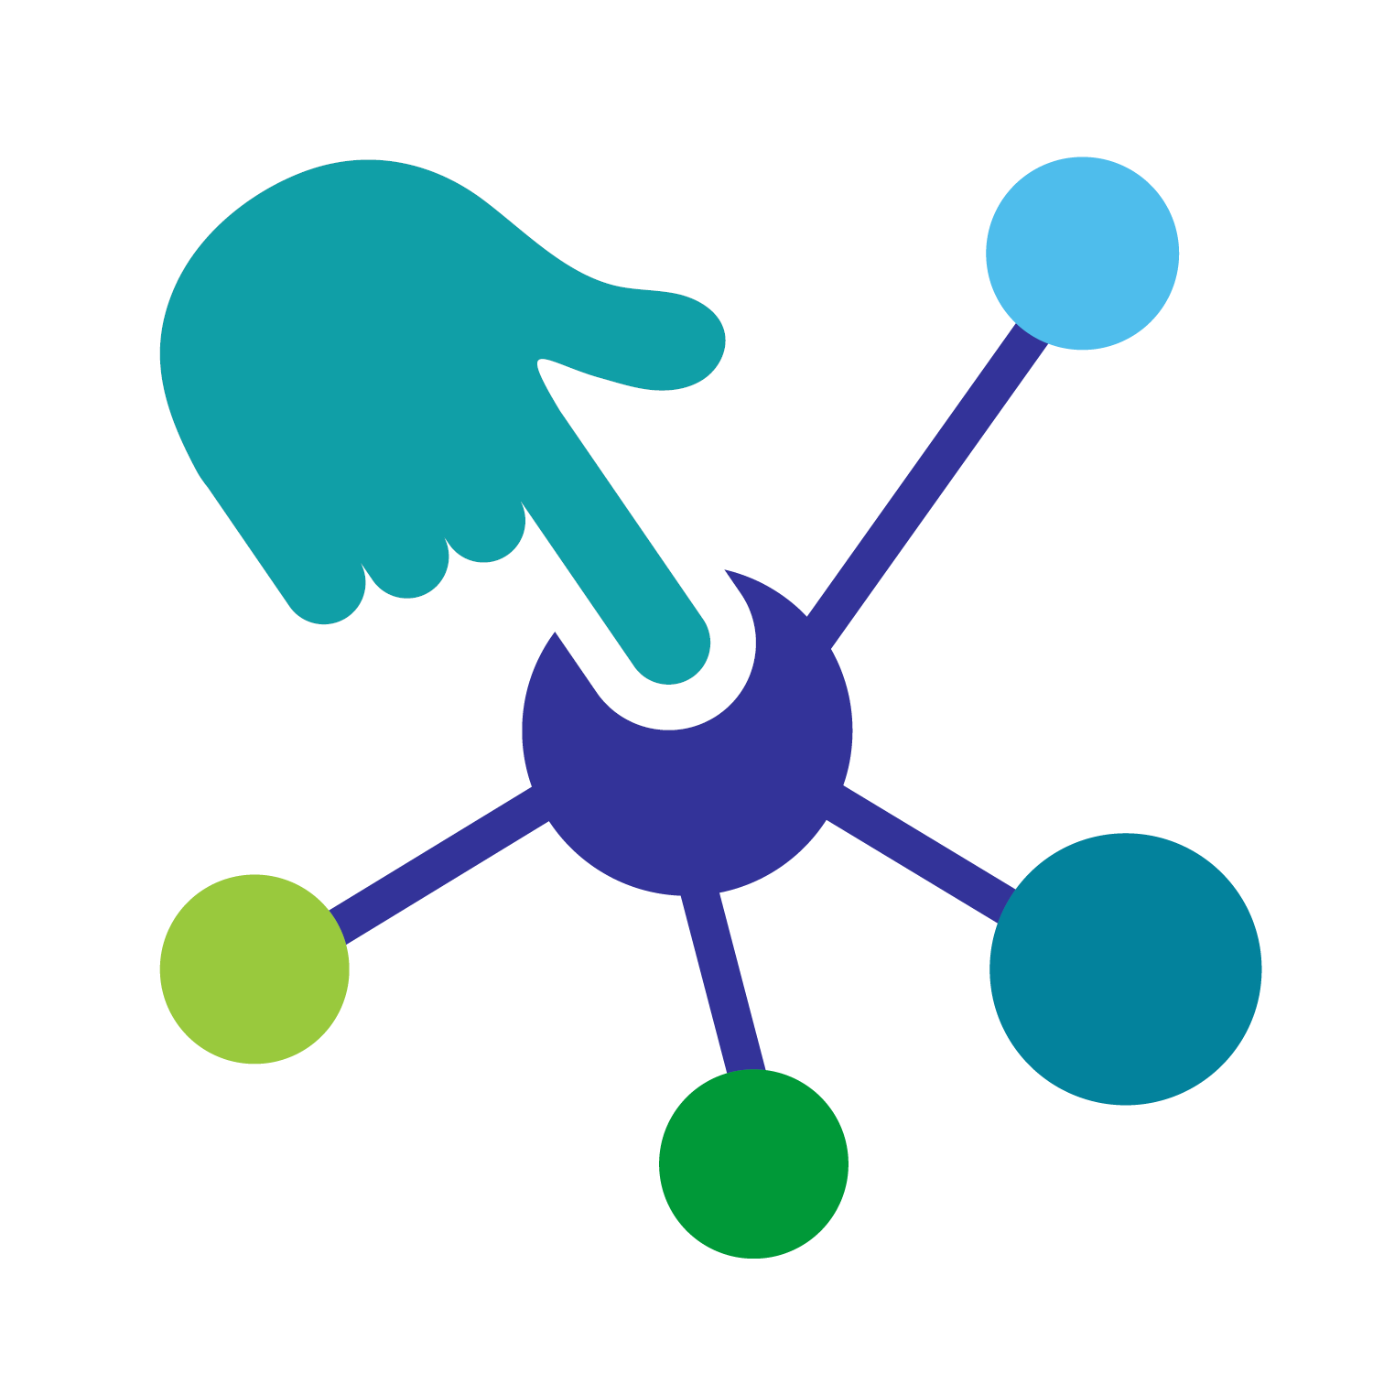 Team Takeaway — A key idea or message to remember and carry forward.
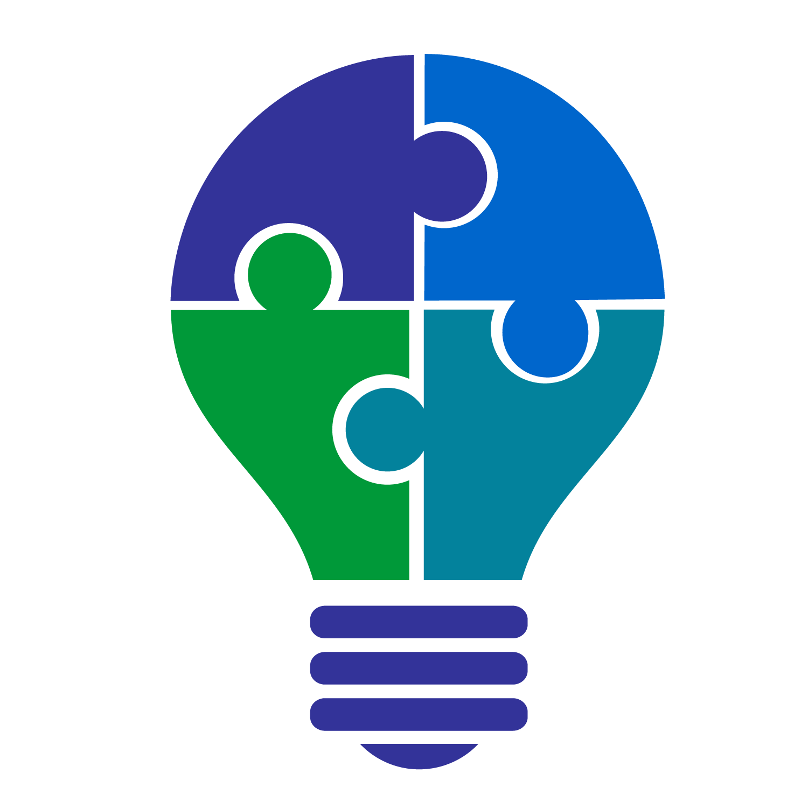 Example — An example of what the ideas can look like when put into practice.

A Playbook for The Team
Use the Playbook as a resource to guide your team’s conversations, support your planning, and strengthen your work together. Return to it whenever the team needs a new idea, a different perspective, or a next step.

Section 1: Understanding the Foundation

Why Community Collaboration Matters

The Importance of a CCoT
Successful transition requires more than what can happen within a school or through a single service system or community-based organization. Youth with disabilities and their families often rely on multiple people, transition partners, and community resources as they prepare for life after high school.
County Communities on Transition (CCoTs) provide a structure for collaboration by bringing together people and organizations that support youth with disabilities during the transition process. Through shared knowledge, coordinated efforts, and collective problem-solving, CCoT members help create stronger pathways to employment, education and training, and independent living within their communities.
As a CCoT member, you have an opportunity to stay informed about local resources and services, build meaningful partnerships, identify and address barriers, and contribute to efforts that improve outcomes for youth and their families.

Improving Outcomes
The transition from high school to adulthood can be complex for youth with disabilities and their families. Navigating employment services, postsecondary education and training options, independent living supports, and community resources often requires guidance and coordination among multiple partners.
CCoTs help create stronger, more connected transition pathways by strengthening communication, collaboration, and a shared understanding among transition partners. When partners understand one another’s roles and responsibilities, they can better coordinate services, identify gaps, and connect youth and families with support when it is needed.
By working together, CCoTs help ensure that youth and their families have access to the information, support, and opportunities necessary to pursue their goals and successfully transition into adult life.

Stronger Support Networks
Building connections among all transition partners creates a more coordinated system of support. Each member can contribute by:
- Accessing and Connecting Resources: Identify available services, funding sources, and community programs while uncovering gaps that may need additional attention.
- Building Stronger Transition Partnerships: Foster lasting relationships that strengthen collaboration, reduce duplication of efforts, and maximize community resources.
- Using Data to Guide Action: Use local and statewide data to identify priorities, guide action planning, measure progress, and identify service gaps affecting youth.
- Creating Greater Community Impact: Work together to develop sustainable solutions that expand opportunities and improve outcomes for youth with disabilities across the community.
- Supporting Postsecondary Outcomes: Help create smoother transitions from high school to adulthood through collaborative planning, coordinated services, and expanded opportunities.

Benefits of a CCoT
Participating in a CCoT offers benefits for youth, families, schools, agencies, organizations, employers, and transition partners alike. When partners work together, the entire community is better positioned to support youth as they prepare for adulthood.
While students are still in school, there are many opportunities for youth and their families to connect with transition partners outside of school district staff. CCoT members can help strengthen these connections by sharing resources, creating opportunities for youth to explore their interests and goals, and building relationships that can continue beyond high school.
The student's Postsecondary Transition Plan (PTP) provides an important opportunity for transition partners to collaborate in supporting the student's goals for life after high school. Transition partners may contribute to the development and implementation of the student's transition services and connections with outside agencies.
Transition planning helps youth with disabilities and their families think about life after high school and identify the skills, experiences, relationships, and supports needed to achieve their goals. CCoTs can play an important role in this process by helping transition partners understand available resources, build partnerships, and identify opportunities that youth can access while they are still in high school.
As your CCoT develops its action plan, consider how your team can create or strengthen opportunities that support students' transition planning and connections to adult life.
Example: The CCoT Team explores the Transition Services Outlined in the PTP resource to become familiar with the types of transition services that may be identified for students while they are still in school. The team then cross-references those services with the programs, resources, and supports offered by CCoT Team members. This helps the team identify where local partners can support transition services and gives them a clearer understanding of how they can work with schools, youth, and families to connect students with available opportunities.
Resource Spotlight: The Transition Services Outlined In the PTP outlines the 6 basic components of the Transition Services/Pre-ETS as outlined by the Workforce Innovation and Opportunity Act (WIOA) law.
Team Activity: As a Team, utilize the Sequencing of Services Template for CCoT Teams excel spreadsheet to see where services overlap and are different.
Wisconsin's Transition Framework
Wisconsin’s transition system is strengthened through collaboration at three interconnected levels: statewide leadership, local community partnerships, and youth and family-centered planning.
Together, these levels create a coordinated approach to supporting youth with disabilities as they transition to adulthood.

What is WiCoT?
The Wisconsin Community on Transition (WiCoT) is a statewide leadership team committed to improving transition outcomes for youth with disabilities across Wisconsin.
WiCoT brings together representatives from state agencies, education, workforce development, higher education, family organizations, advocacy groups, and other transition partners. The team works to identify statewide needs, strengthen transition practices, share resources, and support collaboration across systems.
Through leadership, professional learning, technical assistance, and resources, WiCoT supports local CCoTs and helps connect communities and transition partners across Wisconsin.

What is a CCoT?
A County Community on Transition (CCoT) is a local team of transition partners working together to improve outcomes for youth with disabilities within their communities. Although around the state, transition teams are known as a CCoT, the team may have their own unique name.
CCoTs use local knowledge, partnerships, and data to identify priorities and develop strategies that support youth and families. Team membership may include: Secondary Educators, Parent/Family/Youth, Service Systems, and Community-Based Organizations.
Through collaboration and shared responsibility, CCoTs create opportunities for youth to explore careers, pursue education and training, develop independent living skills, and strengthen self-advocacy skills to prepare them for adult life.
Resource Spotlight: CCoT Team Members is a resource that highlights the potential team members that should be considered for the CCoT Team.

How Do WiCoT and CCoTs Work Together?
WiCoT and CCoTs serve different but connected roles in strengthening transition outcomes for youth across Wisconsin.
WiCoT provides statewide leadership, resources, technical assistance, and opportunities for shared learning. | CCoTs apply this information locally by bringing transition partners together, identifying community needs, and creating solutions that support youth and their families.
This partnership creates a continuous cycle of learning and improvement. Local CCoTs provide valuable insight into community needs and successes, while statewide partners help identify trends, share promising practices, and support local level teams in strengthening transition systems.
Example: A local CCoT identifies a gap in work-based learning opportunities. The team shares the concern with WiCoT. In response, WiCoT helps identify potential partners, resources, and promising practices that may support the local CCoT in addressing the gap and creating new opportunities for students.

Wisconsin’s Pathways to Transition Partnerships
Wisconsin’s Pathways to Transition Partnerships is a framework that connects transition planning efforts across three interconnected levels: state, local, and youth/family. Each level plays a distinct but connected role in supporting positive post school outcomes for youth with disabilities.
The framework reminds us that successful transition is not the responsibility of one person, program, or system. It requires connection and coordination across all three levels.
The graphic below demonstrates the commitment to transition at each level.

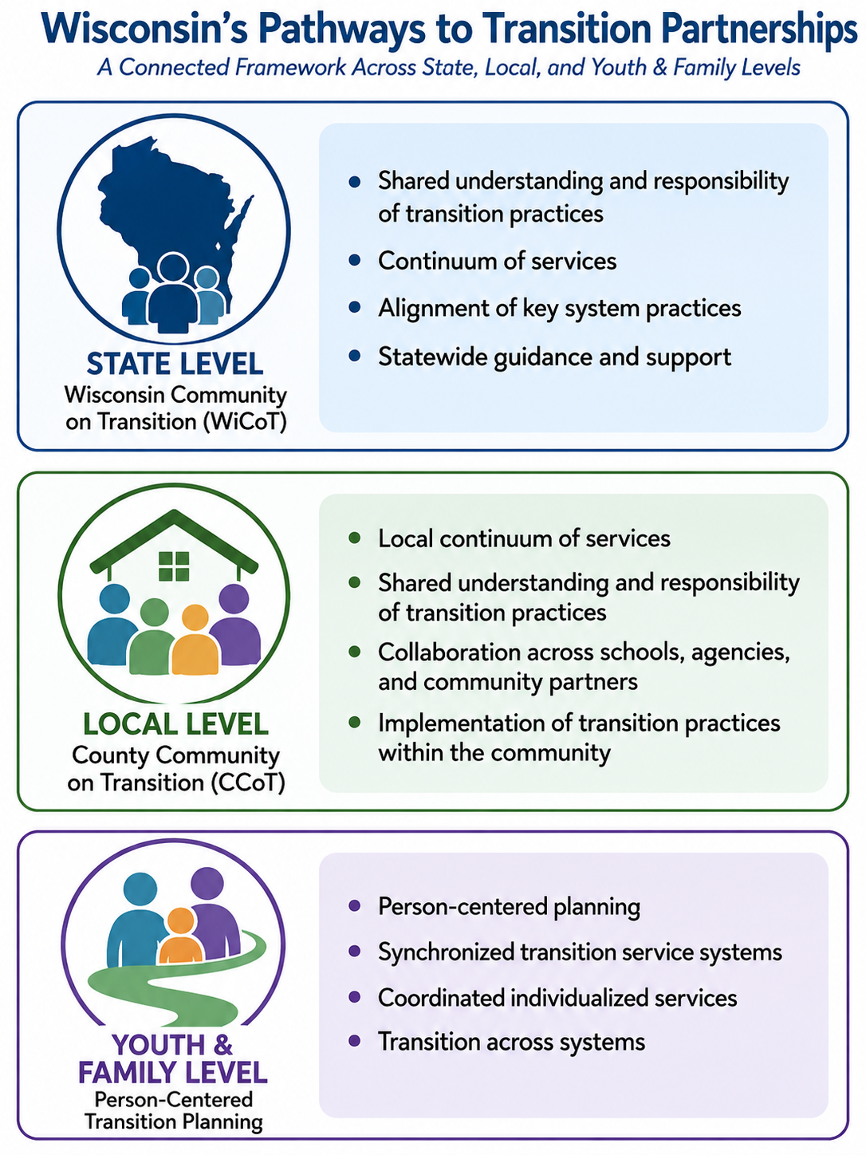
AI Generated Image

Connecting All Three Levels
Together, these three levels—state (WiCoT), local (CCoTs), and youth/family—create a strong, connected foundation for transition planning in Wisconsin. Each level supports the others, helping to align vision, strengthen collaboration, and improve outcomes for youth with disabilities.

Strengthening Alignment Across the System
While these levels are designed to work together, communication and coordination across the system may not always be seamless. Understanding how information, resources, and practices move across the three levels helps identify where alignment is strong and where continued improvement is needed.
For CCoT Teams, this means looking beyond what happens within the team and considering how the team's work connects to youth and families, local systems, and statewide efforts. This awareness supports ongoing reflection and strengthens efforts to build a more connected and responsive transition system.
Team Activity: As a team, utilize the Strengthening Alignment Across Systems activity resource to explore how the team connects with youth and families, local partners, and statewide transition partners.

Section 2: Building Your CCoT Team
A strong County Community on Transition (CCoT) begins with the people at the table. Building an effective team requires intentional leadership, diverse representation, clear expectations, and a shared commitment to improving outcomes for youth with disabilities.
CCoTs are strongest when members bring different experiences, perspectives, resources, and areas of expertise to address community needs. Building a team is not a one-time activity. It is an ongoing process of developing relationships, welcoming new partners, and ensuring the voices of youth, families, and community members remain central to the work.
Establishing CCoT Leadership

The Role of the Facilitator
Each CCoT should identify a facilitator and, when possible, a co-facilitator to help guide the team's work. The facilitator supports the group process by creating structure, encouraging participation, and helping the team remain focused on its shared purpose.
Example: The CCoT Team is starting to work towards building their team. An educator and agency member decide to co-facilitate the group. The educator brings knowledge of the student, their transition journey so far, and the school-based supports that are provided to students. The agency member brings an understanding of the youth and adult systems, community resources, and opportunities beyond high school. Together they provide a well-rounded perspective to facilitate the team.
A facilitator is not the person who makes all the decisions or directs the work. Instead, the facilitator creates an environment where all members can contribute, share ideas, and participate in meaningful discussions.
Effective facilitators:
- Guide conversations and keep meetings focused on team priorities.
- Ask thoughtful questions that encourage reflection and problem-solving.
- Recognize and support different communication styles and perspectives.
- Create opportunities for all members to participate.
- Help the team navigate disagreement or challenging conversations.
- Reinforce the team's collective commitments and meeting expectations.
Every facilitator has a unique style, and every CCoT has its own group dynamics. Strong facilitators adapt their approach based on the needs of the team and intentionally create opportunities for all voices to be heard.
Participation may look different for different team members. Some members may feel more comfortable sharing in smaller groups rather than large discussions. Strategies such as breakout conversations, reflection activities, or rotating discussion leaders can help create meaningful opportunities for everyone to contribute.

Building The CCoT Team

Identifying Transition Partners
Strong CCoTs begin by bringing together partners who can contribute to the team's goals.
Identifying team members can feel overwhelming when starting a new team. Begin by considering the team's priorities, along with its vision, purpose, and mission, if these have already been established. Consider existing partnerships, organizations, and community assets that can strengthen the team's work.
Resource Spotlight: Watch this short Community Asset Mapping video which highlights and identifies community assets.
Building on existing relationships and community strengths can help avoid duplication, expand capacity, and create opportunities for deeper collaboration.
Consider:
- Who needs to be part of this conversation?
- Whose knowledge, experience, or resources will help us achieve our goals?
- Whose voice or perspective may be missing?
- What existing partnerships, organizations, or community assets can support this work?
- Where are there opportunities to strengthen or build new partnerships?
Potential CCoT members may include:
- Secondary educators
- Youth and families
- Service systems
- Community-based organizations
- Employers and business partners
- Other individuals or organizations with a role in supporting youth as they prepare for adulthood
Resource Spotlight: The CCoT Team Members resource provides a list of potential individuals to consider when identifying transition partners.
When inviting new members, clearly communicate:
- What a CCoT is
- Why community collaboration matters
- How their participation contributes to youth outcomes
- What role they can play in supporting the team's work
Team members are more likely to engage when they understand the purpose of the work and see the value of their contribution.
Team Activity: As a team, complete the CCoT Membership & Recruitment Matrix to assess team representation, identify gaps, and design a plan to recruit new members.

Assessing Team Representation
Strong CCoTs regularly reflect on whether the right partners, perspectives, and voices are represented.
Pause & Reflect: As your team grows and changes, consider the following questions:
- Are youth and families represented and meaningfully engaged?
- Are education, service systems, employers, and community organizations represented?
- Are we including perspectives from individuals and communities who may experience barriers?
- Are there voices, experiences, or areas of expertise missing from the team?
- Are our meeting structures and communication methods allowing everyone to participate?
A strong team does not simply focus on who is present—it also considers who may be missing.
CCoTs can strengthen representation by:
- Reviewing membership regularly
- Identifying gaps in expertise, experience, or perspective
- Building intentional recruitment strategies
- Creating multiple ways for members to participate and provide feedback
These reflections are intended to support continuous improvement, not evaluate team performance. The goal is to help the team notice who is at the table, who may be missing, and what can be done to create more meaningful participation.
Pause & Reflect: As a team, how well are we doing?
- We include partners from multiple systems and backgrounds
- We value the experiences of youth, families, educators, agencies, employers, and community partners
- We create meaningful opportunities for participation
- We use feedback to improve collaboration
- We regularly review membership and seek new partners when needed
Team Takeaway: Strong representation is not about having the largest team possible. It is about having the right voices, perspectives, and expertise to understand community needs and move the team's priorities forward.
Recruiting and Onboarding CCoT Team Members
Strong CCoTs are built through intentional recruitment and effective onboarding. As members change roles, transition needs evolve, and new partnerships develop. Teams need ongoing strategies for bringing new voices to the meetings.

Recruiting New Members
Recruitment is most successful when current members can clearly communicate:
- Why the CCoT exists
- Why collaboration matters
- How the team is improving opportunities for youth and families
- How a new partner’s knowledge and experience can contribute
Potential recruitment strategies include:
- Personal invitations from current members
- Recommendations from transition partners
- Outreach through existing networks
- Sharing information at community events
Resource Spotlight: Use the downloadable Join Your CCoT flyer as a starting point to create a personalized flyer for recruiting new CCoT members.
Resource Spotlight: Utilize the sample downloadable Email to Service Systems and Community-Based Organizations, Email to Family and Student, Email to Director of Special Education and School Districts, and an Email Approval to Attend CCoT Meetings template to invite new members to the team.
Team Activity: As a team, complete the Building a CCoT Team Reflection Matrix resource to provide the team with insights into who the team may be missing to carry out the team’s priorities and goals.
The Importance of Onboarding
Welcoming a new member is the first step in building engagement. Effective onboarding helps new members understand:
- The purpose and goals of the CCoT
- Team structure and meeting expectations
- Current priorities and activities
- Their role in supporting the team’s work
A strong onboarding process helps new members feel welcomed, prepared, and connected.
Onboarding may include:
- Sharing the team’s vision, purpose, and mission
- Reviewing collective commitments/team norms
- Connecting new members with existing team members
- Providing background information and current action steps
- Creating opportunities for questions and discussion
A thoughtful onboarding process helps members feel welcomed, connected, and prepared to participate, increasing the likelihood that they will remain engaged over time.
Resource Spotlight: The TIG CCoT Onboarding Plan is a customizable, fillable tool designed to support the onboarding of new members. Teams can adapt the plan to fit their local needs and use it to help new members understand the team's purpose, structure, goals, and opportunities for involvement.

Defining Roles and Responsibilities
Clear roles and responsibilities help CCoT members understand what is expected of one another, how work gets done between meetings, and how the team maintains shared accountability.
Clear expectations also help prevent the work from falling on only a few members.
Pause & Reflect: As a team, discuss the following questions:
- What does active participation look like?
- How will we communicate between meetings?
- How will decisions be made?
- How will we share responsibility for action planning and activities?
- How will we ensure leadership is shared?
Clear roles help strengthen follow-through, create shared ownership, and support a more sustainable team.
Resource Spotlight: The Belonging Mindset Card, provides insights into belonging on a team, including questions to ask, sample practices, common pitfalls, and resources.

Collective Commitments (Team Norms)
Collective commitments, sometimes called team norms, establish how the CCoT will work together.
These agreements create a foundation of trust, respect, accountability, and shared responsibility. They help teams engage in meaningful conversations, including conversations that may be challenging or require different perspectives.
One example set of commitments is drawn from the ‘Four Agreements of Courageous Conversations’.
- Stay engaged: Remain actively involved—emotionally, intellectually, and socially—in the dialogue.
- Expect to experience discomfort: Recognize that discomfort is a natural part of meaningful conversations, especially when addressing complex or sensitive topics.
- Speak your truth: Share thoughts and perspectives honestly rather than saying what others may want to hear.
- Expect and accept a lack of closure: Be willing to remain in uncertainty and continue the dialogue without rushing to immediate solutions.
Teams may adopt these commitments, adapt them, or create their own agreements.
Team Activity: As a Team, complete the Creating Our Collective Commitments activity to help create a team environment where members feel respected, heard, included, and responsible for the work within the team.
When teams intentionally define how they will work together, they create stronger relationships, better communication, and a stronger foundation for collective action.
Team Takeaway: Strong transition systems depend on strong connections. WiCoT, CCoTs, and youth and families each play an important role in strengthening transition outcomes. When information, resources, and feedback move across these levels, communities are better positioned to identify needs, build partnerships, and create opportunities for youth with disabilities.

Section 3: Meeting Structures

Creating Meeting Structures that Support Action
Strong CCoTs recognize that effective meetings are about more than sharing information. Meetings provide the structure needed to build relationships, make decisions, solve problems, and move shared priorities into action.
Intentional meeting structures help teams:
- Create consistent communication among partners
- Ensure all members have opportunities to participate
- Maintain focus on shared priorities
- Monitor progress and address barriers
- Build accountability between meetings
Every CCoT will develop meeting practices that reflect the needs of its team. The goal is not to create a perfect meeting structure, but to establish predictable practices that help members understand expectations, participate meaningfully, and stay connected to the team's purpose.

Determining Meeting Frequency and Format
There is no single meeting schedule or format that works for every CCoT. Teams should consider their priorities, membership, and capacity when determining how often and where they will meet.
Pause & Reflect: As a team, consider the following questions:
- How often does the team need to meet to maintain momentum?
- What work needs to happen during meetings?
- What meeting format will make participation most accessible?
- When are members most likely to be available?
- What information or decisions need to be addressed between meetings?
Meeting frequency may change as the team's needs change. Some teams may meet monthly, while others may meet quarterly or use a combination of larger team meetings and smaller workgroups.
The important thing is to establish a structure that provides enough consistency to maintain relationships and momentum while respecting members' time and capacity.

Choosing the Right Meeting Format
CCoTs may use different meeting formats depending on the purpose of the gathering.

Whole Team Meetings
Whole team meetings bring partners together to:
- Build relationships and communication
- Share information and resources
- Discuss community priorities
- Make decisions
- Coordinate efforts
Whole team meetings may occur in person, virtually, or through a hybrid format.
In-Person Meetings
In-person meetings can be especially valuable for:
- Relationship-building
- Strategic planning
- Complex discussions
- Collaborative activities
- Problem-solving.
Virtual Meetings
Virtual meetings can support:
- Regular communication
- Progress updates
- Decision-making
- Maintaining momentum between larger gatherings
Hybrid Meetings
Hybrid meetings allow members to participate either virtually or in-person and can:
- Increase accessibility
- Provide flexibility
- Support participation when travel or schedules create barriers
Team Takeaway: Consider the purpose of the meeting when selecting the format. A team may find that some work is best completed in-person, while other work can be handled effectively through virtual meetings

Core Team and Business Team Structure
Some CCoTs may choose to create different levels of participation to support both focused leadership and broad community engagement.
Core Team
A smaller group of committed members who help coordinate the CCoT’s work, develop action steps, and support implementation.
Core Team members may:
- Prepare meeting agendas
- Advance priorities between meetings
- Coordinate workgroups or initiatives
- Support communication across partners
- Monitor progress on action steps
Business Team Meetings
A broader group of members who:
- Provide input and share resources
- Support implementation
- Connect the work to the larger community
- Help expand awareness and opportunities for youth
This structure allows a CCoT to maintain a strong focused working group while continuing to engage a broad network of transition partners.
Teams should determine which meeting formats and participation levels best support their goals and allow members to contribute meaningfully as determined by the team.

Creating Purposeful Agendas
An agenda is more than a list of topics. It is a tool that helps the team focus its time and energy on what matters most.
Effective agendas balance:
- Relationship-building
- Information sharing
- Discussion
- Decision-making
- Action planning
Whenever possible, agendas should be developed collaboratively and shared in advance. This allows members to prepare, gather feedback from others outside of the team, and participate fully.

Elements of an Effective Agenda
A strong agenda may include:
- Presenter/Facilitator: Who will guide the discussion
- Time: Keeps the meeting on schedule
- Topic: Clearly identifies discussion items
- Purpose: Clarifies whether the item is for information, discussion, or decision-making
- Relevant Materials: Identifies information members should review before the meeting
- Action Items/Notes: Documents decisions, responsibilities, and next steps
Additional sections may include:
- Upcoming meeting dates
- Team membership and contact information
- Meeting roles and responsibilities
- Team collective commitments
- Relevant tools and resources
Recurring agenda topics may include:
- Welcome and relationship-building activities
- Celebrations, accomplishments, and small wins
- Liaison updates and partner report-outs
- Review of action plan progress
- Workgroup updates
- Data review and discussion
- Decision-making opportunities
- Identification of next steps, responsibilities, and timelines
- Reflection on meeting effectiveness
- Future agenda items
Team Takeaway: Using a consistent agenda template to help members prepare for meetings, know what to expect, and build interest is a key to shared responsibility within CCoT Teams.
Resource Spotlight: Use the sample CCoT Agenda as a guide for developing an agenda for your team meetings. It provides an example of how to structure your meeting and organize time for discussion, activities, and action planning. The team can also adapt the fillable CCoT Agenda Template.

Common CCoT Meeting Roles

Clearly defined meeting roles help distribute responsibility, increase engagement, and prevent the work from falling on only a few members.

Common roles include:

Facilitator/Co-Facilitator: Guides discussion, supports participation, and keeps the team focused

Timekeeper: Monitors pacing and helps ensure the team uses meeting time effectively

Note Taker: Documents key discussion points, decisions, and action steps

Process Observer: Reflects on group participation and helps ensure the team's collective commitments are being followed

Big Ideas Capturer: Summarizes key takeaways, decisions, and action steps for sharing with team members and stakeholders

Liaison: Shares relevant information, updates, and resources with districts, agencies, organizations, and community partners

Data Coordinator (Optional): Supports the collection, organization, and sharing of data to guide team decision-making

Teams may rotate some roles to increase engagement and develop leadership capacity. Other roles, such as facilitation, may remain consistent to provide continuity. Not every CCoT needs every role. Teams can adapt roles based on their meeting structure and needs.

Supporting Shared Responsibility
Strong CCoTs recognize that everyone has a role in moving the team's work forward. Shared responsibility helps distribute the work, increase ownership, and strengthen communication across systems.
Teams can support shared responsibility by:
- Rotating meeting roles when appropriate
- Assigning clear responsibility for action steps
- Establishing timelines and due dates
- Creating workgroups or smaller teams when needed
- Asking members to share relevant information with their organizations and bring feedback back to the CCoT
- Reviewing progress regularly
When responsibilities are shared, team members are more likely to see themselves as contributors to the CCoT's success rather than simply meeting participants.

Moving from Meetings to Action
The work of a CCoT continues between meetings. Strong teams establish simple processes that support communication, follow-through, and accountability.
Strategies may include:
- Sharing meeting notes and action items promptly
- Assigning responsibility for action steps
- Establishing timelines and due dates
- Monitoring progress toward goals
- Creating workgroups or smaller teams when needed
- Sharing updates at future meetings
Clear follow-through helps ensure that ideas become meaningful actions.

Big Idea Summary
One simple strategy is to close each meeting by identifying:
- One decision the team made
- One action step the team is taking
- One question or idea to bring back to coworkers or other partners

Parking Lot Strategy
Not every topic can be addressed during a meeting. A parking lot provides a place to capture important ideas, questions, or concerns that may require future discussion. These topics can be added to the next agenda.

Report Back
At the beginning of the next meeting, provide time for:
- Parking lot topics from previous meetings
- Progress on action steps
- Information the team should know
These simple practices help strengthen connections across systems and ensure the CCoT's work reaches beyond the meeting room.

Reflecting on Meeting Effectiveness
As the team grows and evolves, meeting structures should be reviewed periodically to ensure they continue to meet the needs of members.
Pause & Reflect: Consider the following questions as the team grows and evolves:
- Are meetings productive and action-oriented?
- Do all members have opportunities to participate?
- Are agendas aligned with team priorities?
- Are decisions and next steps clear?
- Is the team making progress toward its goals?
- What challenges or barriers are limiting progress?
- Where are there gaps or disconnects among transition partners?
- What successes should the team celebrate?
Gathering feedback and making adjustments helps teams create meeting structures that remain effective as the CCoT evolves.

Connecting to the Bigger Picture
The Transition Action Guide can support teams in further defining roles and responsibilities within transition planning work.
Reviewing this resource as a team can help clarify how responsibilities are distributed across partners and how collaborative action supports student outcomes.
Resource Spotlight: Review the Transition Action Guide (TAG) as a team to gain clarity and understanding of the roles and responsibilities of transition partners in the transition planning process.

Team Takeaway: Effective CCoT meetings are intentionally designed to build relationships, focus the team's time, support shared decision-making, and move priorities into action. Strong meeting structures create the consistency, shared responsibility, and accountability needed to keep the team's work moving between meetings.

Additional Support
Facilitators and team members are encouraged to participate in CCoT Network Meetings and CCoT Facilitator Network Meetings to:
- Share ideas and successes with other CCoTs
- Learn from the experiences of other CCoTs
- Access technical assistance and resources
- Strengthen local team efforts
Resource Spotlight: View the Statewide CCoT Network flyer for meeting dates, times and meeting details.
Technology Resources Options for CCoT Meetings.
Finding the right virtual meeting platform to meet the needs of all CCoT Team members can be challenging. The best option may depend on what platforms team members already have access to, the features your team needs, and whether there is a cost.
Resource Spotlight: Explore these commonly used virtual meeting platforms and their support resources to help your CCoT Team select and use a platform that meets the needs of your team members.

- Video: Zoom Tutorial for Beginners, Zoom Support Article
- Video: Microsoft Teams (purchase required), Microsoft Support
- Video: Webex tutorial, Webex Support
- Video: Google Meet, Google Meet Support

Section 4: Establishing a Shared Direction
Creating Alignment Through Vision, Purpose, and Mission
A strong CCoT begins with a shared understanding of why the team exists, what it hopes to accomplish, and how members will work together to create meaningful change.
Developing a vision, purpose, and mission gives the team a common direction. These statements help members connect their individual roles, experiences, and organizational priorities to a shared community goal.
A shared direction can:
- Guide decision-making
- Help the team identify and prioritize its work
- Provide a foundation for action planning
- Strengthen commitment and shared responsibility
- Help the team communicate its purpose to others
- Keep the team focused on improving outcomes for youth with disabilities
A shared direction is more than a statement written once and placed in a document. It should be something the team uses to guide its work and help move the CCoT beyond “just another meeting.”
Resource Spotlight: The downloadable CCoT Team RESET PowerPoint provides slides to walk a team through the process of creating or refining the team’s vision, purpose, and mission.

Developing a Vision Statement
Where Do We Want to Go?
A vision statement describes the future a CCoT hopes to create. It represents the long-term impact the team wants to have for youth with disabilities, families, and the community.
A strong vision helps members look beyond current challenges and imagine what is possible when partners work together.
An effective vision statement is:
- Future-focused
- Inspiring and meaningful
- Inclusive of youth, families, and community partners
- Connected to improved outcomes for youth with disabilities
When developing or revisiting a vision statement, teams should consider the changes they hope to see in their community and how their collective efforts can help create that future.
Pause & Reflect: A strong vision should help the CCoT Team picture what success looks like and understand how each team member can contribute. Consider the following questions:

- If we achieved this outcome, success would look like...
- I see my role and contributions aligning with the CCoT vision statement in the following way(s)...

Purpose Statement (Values)
Why Do We Exist?
A purpose statement provides clarity, direction, and inspiration for the CCoT's work. It describes the deeper reason the team comes together and the impact members hope to have on youth with disabilities, their families, and the community.
A strong purpose statement:
- Reflects the needs of youth and families
- Recognizes the importance of collaboration
- Connects partners around a shared commitment
- Provides meaning and motivation for the team’s work
The purpose should remind members that although each partner may have a different role, everyone contributes to improving transition outcomes.
Pause & Reflect: A clear purpose helps the CCoT Team understand why the team exists, what it hopes to accomplish, and why the work matters. Consider the following questions:
- Our team exists for/to...
- If our team were to achieve one impactful result this year, it would be...
- Our purpose motivates me to keep showing up because/to...
- We know we're making a difference when...

Mission Statement
How Will We Get There?
A mission statement describes what the CCoT does, who it serves, and how the team will work toward its vision.
While the vision describes the future the team hopes to create, the mission describes the actions the team will take to move toward that future.
An effective mission statement:
- Clearly communicates the team’s role
- Identifies who the team serves
- Reflects the collaborative nature of the work
- Provides direction for planning and decision-making
Pause & Reflect: A mission statement should help guide your team’s priorities and describe the change you want to create. Consider the following:
- The change we want to see in our community because of our work is...
- We can work together to serve our youth with disabilities by…
Team Activity: As a team, complete the Building The Foundation-Vision, Purpose & Mission activity resource to develop a shared understanding of where the team is headed, why the team exists, and how the team will work together.

Bringing It All Together
A shared vision, purpose, values, and mission provide the foundation for an effective CCoT.
Together, these elements:
- Create a common direction
- Connect partners around shared goals
- Guide decision-making and action planning
- Support shared accountability
- Help communicate the importance of the CCoT’s work
- Provide a reference point when the team needs to make decisions about priorities
When developed collaboratively, these statements help ensure that members understand where the team is going and how they each contribute to the work.
CCoTs should revisit their shared direction regularly to ensure it continues to reflect:
- The needs and experiences of youth and families
- Community strengths and opportunities
- Changing priorities and partnerships
- Progress toward desired outcomes
Team Takeaway: Our shared direction belongs to the whole team. Vision, purpose, and mission help us understand where we are going, why the work matters, and how we will work together to create meaningful change for youth and families.

Section 5: Knowing Your Community to Identify Priorities

Turning Information Into Shared Priorities
Meaningful action begins with understanding the community a CCoT serves.
Before deciding what the team should accomplish, members need to understand the strengths, opportunities, needs, and challenges within their community. Using information to guide decisions helps teams move beyond assumptions and individual experiences and focus their collective efforts where they can have the greatest impact. Data does not need to be complicated. At its core, data is simply information that helps teams better understand what is happening.
The purpose of using data is not to collect information for the sake of collecting it. Data helps teams:
- Understand the experiences of youth and families
- Identify community strengths and opportunities
- Recognize barriers and gaps
- Identify priorities for action
- Monitor progress
- Celebrate success
Team Takeaway: The team does not need perfect data to begin. Start with the information available, ask meaningful questions, and use what you learn to guide team conversations and decisions.

Why Data Matters
Successful CCoTs use information to better understand their community and make informed decisions together.
Without data, teams may rely primarily on individual experiences, assumptions, or “the way things have always been done.” Individual experiences are valuable, but combining different sources of information provides a more complete picture.
Using data helps teams:
- Identify transition strengths and challenges
- Recognize service gaps and barriers
- Understand different experiences among youth populations
- Determine priorities for improvement
- Select strategies that address identified needs
- Measure progress over time
- Strengthen collaboration among partners
Data creates a shared starting point for conversation and helps teams determine where collective action can make the greatest difference.

Understanding Different Types of Data
When people hear the word “data,” they often think about numbers, reports, and charts. While formal data is important, data includes much more than statistics.
CCoTs should consider both formal data and community knowledge/informal data when making decisions.

Formal Data
Formal data is structured information that is collected and analyzed consistently. It helps teams identify trends, measure outcomes, and monitor progress.
Examples include:

Graduation and dropout rates

Postsecondary outcome data

Employment and workforce data

Transition assessment results

School, district, county, or state reports

Attendance and participation data

Survey results

Community Knowledge and Informal Data
Informal data includes the experiences, observations, and perspectives of individuals connected to the transition process.
Examples include:

Student and family feedback

Input from educators and service providers

Observations from team members

Community conversations

Success stories and lived experiences

Feedback gathered during meetings, events, or focus groups

Combining Information for a Complete Picture
The strongest decisions happen when teams use multiple sources of information together.
Example: Formal data may show that employment outcomes for youth with disabilities are lower than expected. Conversations with students, families, employers, and service providers may help explain why those outcomes exist and what changes may be needed.
Team Takeaway: Numbers help identify trends. Experiences help explain the story behind those trends. Together, they help teams determine meaningful action.

A Simple Process for Using Data

Data-based decision-making is not a one-time activity. Effective teams review and use data regularly to monitor progress and adjust their efforts as needed.

Teams use data throughout the year to identify priorities, develop action plans, monitor implementation, measure progress, and celebrate success. Regular reflection helps teams remain responsive to changing community needs and continue improving transition outcomes.
Team Activity: As a team, utilize A Simple Process for Using Data activity resource as a starting point to collecting data.

Team Takeaway: When discussing data, start with questions rather than answers. Team members share their observations, perspectives, and experiences before jumping to solutions.

Using Local Data to Understand Your Community

CCoTs have access to a variety of information that can help them better understand their community.

Team and Support System Information

Team reflection information can help identify:

Who is represented on the CCoT

Who regularly participates

Which perspectives may be missing

How often the team meets

How partners communicate and collaborate

Collaboration and Communication

Teams can examine how schools, agencies, organizations, businesses, families, and other partners communicate and work together.

Consider:

What services and resources are available?

How do partners communicate?

Where are there gaps or disconnects?

How does the team communicate its work with administrators and other stakeholders?

Post-School Outcomes

Post-school outcome data provides information about what students are doing one year after leaving high school, including education, competitive employment, and other post-school activities.

Resource Spotlight: Special Education Post School Outcomes Interactive Map

The Special Education Post School Outcomes Interactive Map video provides an overview of how to use the map.

County Labor Market Information

Labor market information can help teams understand employment opportunities and workforce needs within their communities.

Resource Spotlight: Wisconomy

Teams can use Wisconomy tools to explore county and regional labor market information and consider how workforce trends may connect to transition planning.

Team Takeaway: Invite team members to bring relevant data or reports from their school districts, agencies, organizations, or businesses. CCoTs can also collect information from events, surveys, and other community activities.

The Goal of Using Data
The goal of using data is simple:
To better understand our community, make informed decisions together, and create opportunities that improve outcomes for youth with disabilities.
When CCoTs use information thoughtfully, they are better equipped to strengthen partnerships, address barriers, focus resources, and identify meaningful priorities.
Team Takeaway: Data is not about having all the answers. It is about asking better questions together, understanding our community, and using what we learn to decide where our collective efforts can make the greatest difference.

Section 6: From Shared Priorities to Collective Action

Turning Ideas Into Meaningful Change
A strong CCoT does more than identify needs, it takes action to address them.
By this point, your team has:
- Built relationships among transition partners
- Established how the team will work together
- Created a shared vision, purpose, and mission
- Reviewed community information and data
- Identified shared priorities
The next step is turning that shared understanding into action.
An action plan provides a roadmap for the CCoT's work. It connects the team's priorities, resources, partnerships, and shared commitment to specific activities designed to improve transition outcomes for youth with disabilities and their families.
Action planning is not about creating a checklist for one person to complete. It is a collaborative process where team members:
- Identify priorities
- Determine meaningful actions
- Share responsibility
- Monitor progress
- Adjust strategies when needed
- Celebrate successes
Team Takeaway: The strongest action plans reflect the knowledge, experiences, and resources of the entire CCoT Team.

Creating an Action Plan
Every CCoT needs a way to organize and monitor its work. Some teams use a simple planning template, while others use an online planning platform.
The tool itself does not create success. The team's commitment to using the plan does.
An effective action plan becomes a tool for ongoing discussion, decision-making, follow-through, and accountability.
The Wisconsin Community Transition Innovation Plan (CTIP) is one example of a planning platform designed to support CCoT teams by guiding them through:
- Reviewing community information
- Selecting activities and strategies
- Developing action steps
- Monitoring progress
- Reflecting on outcomes
Teams may use CTIP or another planning process that meets their community’s needs.
Resource Spotlight: Create an account and view the Wisconsin Community Transition Innovation Plan (CTIP). The CTIP User Guide is a helpful tool to assist the user with navigating the site.
If you are interested in learning more about the CTIP or WiCoT, connect with a member of the Transition Improvement Grant (TIG) staff or WiCoT Team to learn more.
A simple example the team could adapt to meet their needs is the CCoT Action Planning Matrix.
Resource Spotlight: Utilize the fillable CCoT Action Planning Matrix during team action-planning to break down CCoT priorities into manageable, accountable steps. A sample CCoT Action Planning Matrix is also available as an example of team action planning.

Begin with Your Community Data
Strong action plans begin with the information and priorities identified in Section 5.
Before selecting activities, discuss:
- What strengths can we build upon?
- What challenges or gaps need attention?
- What barriers impact youth and families?
- Which needs should be addressed first?
- What actions/activities would have the greatest impact?
- Who needs to be involved?
Effective action planning combines data with the knowledge and experiences of team members.

Selecting Meaningful Priorities
Most communities identify many possible areas of improvement. While it may be tempting to address everything, successful teams focus their energy on a few meaningful priorities.
When selecting priorities, consider:
- Does this align with our vision, purpose, and mission?
- Does it address a need identified through information or data?
- Will it improve opportunities or outcomes for youth and families?
- Do we have the partnerships and resources needed?
- Is this realistic for our team to accomplish?
- Can we measure progress?
Team Takeaway: A priority should be important enough to matter and realistic enough for the team to act on.

Building the Foundation First
Not every CCoT needs to begin by launching a new initiative or community event.
The Wisconsin CCoT Pilot Project found that many successful teams begin by strengthening the foundation of their CCoT team.
Examples include:
- Recruiting diverse representatives who represent the community
- Increasing youth and family engagement
- Establishing team roles and expectations
- Developing shared vision, purpose, and mission
- Improving communication among transition partners
As teams become more established, they often expand their work to activities such as:
- Community mapping to identify available transition resource
- Initiative mapping to understand existing community efforts and avoid duplication.
- Educator outreach and professional learning to school district staff within their communities
- Strengthening partnerships among schools, agencies, employers, and community organizations
- Increasing youth and family engagement
- Improving transition events and joining other community activities
- Improving connections among existing assets within the community
These activities build stronger systems of support and create more coordinated transition services for youth and families.
The goal is not to do more. The goal is to identify the actions that will make the greatest difference.
Developing Action Steps
Once the team has identified a priority, break it into specific, manageable action steps.

Goal or Activity
What does the team want to accomplish?
Example: The CCoT team facilitates clear communication and understanding of services offered by school districts, service systems, and community-based organizations for youth transition.

Activity Planning/Action Steps
What specific activities need to happen?
Consider:
- What needs to happen first?
- What steps are required?
- Who needs to be involved?
- What resources are needed?
- When should the steps be completed?

Person(s) Responsible/Share Responsibility
Identify the team member or workgroup responsible for each action step.
Shared ownership strengthens accountability and allows team members to contribute their unique expertise.

Planning Meaningful Transition Events
Many CCoTs include activities such as transition fairs, career events, resource nights, or family learning opportunities within their action plans.
These activities can create valuable connections, but they should support the team’s larger goals—not become the goal themselves.
Before planning an event, consider:

Purpose
- What need or priority will this activity address?
- How does this connect to our vision, purpose, and mission and priorities?

Audience
- Who are we trying to reach?
- Does this include youth and families who may experience barriers?
- Are there groups we are not currently reaching?

Impact
- What do we hope will happen as a result?
- How will we know whether the activity was successful?
- What feedback will we gather?
- How will we use what we learn?
Team Takeaway: A successful transition activity is not measured only by attendance. Success is measured by whether it creates meaningful connections, increases access to opportunities, and contributes to improved outcomes for youth and their families.

Examples of CCoT Activities
CCoTs can adapt activities to fit their community priorities and capacity.

Community Conversations
Bring schools, agencies, organizations, businesses, families, youth, and community partners together to learn about needs, build relationships, and identify opportunities for collaboration.

Community Mapping
Explore community resources, services, businesses, and opportunities available to youth and families. Mapping can help teams identify strengths, gaps, and connections that may not be obvious.

Business or Career Experiences
Partner with local businesses to provide youth with opportunities to explore careers, learn about workplace expectations, and build connections with employers.

Postsecondary Visits
Connect youth with colleges, technical colleges, training programs, or other postsecondary settings to increase awareness of education and training opportunities.

Transition Events
Host resource fairs, career events, family learning opportunities, or other activities that connect youth and families with transition partners and resources.

Monitoring Progress and Celebrating Success
An action plan is a living document. Teams should review it regularly to:
- Celebrate accomplishments
- Identify barriers
- Measure progress of the team’s activities
- Adjust timelines or strategies
- Determine next steps
- Maintain shared accountability
Progress does not have to be measured with complex data. Teams can use simple measures that reflect the goals in their action plan, such as:
- Participation or attendance
- New partnerships or community members engaged
- Resources developed or shared
- Action steps completed by the target date
- Feedback from youth, families, or community partners
- New opportunities created
- Observable changes related to the team's goals
- Identified platforms in which all members can participate
Reviewing these measures regularly helps teams understand what is working, identify where additional support is needed, and make informed adjustments.

Celebrate Progress
Teams should also make time to recognize progress, both large and small.
Celebrating success:
- Builds momentum
- Reinforces the value of collaboration
- Helps members see the impact of their work
- Recognizes individual and team contributions
- Strengthens commitment to continued improvement
- Encourages sustained engagement and participation

Review Your Action Plan
Take time to review your current action plan.
- Does our priority connect to a need identified through community information?
- Does it align with our vision, purpose, and mission?
- Have we clearly identified what we want to accomplish?
- Are responsibilities shared among team members?
- Do we know how we will measure progress?
- How will we know whether our work is making a difference?
- What is one next step we can take?
Team Takeaway: Action planning turns our shared priorities into shared responsibility. A strong CCoT action plan does more than list activities—it identifies meaningful actions, distributes responsibility, monitors progress, and helps the team create measurable change for youth and families.

Section 7: Sustaining Momentum and Continuous Improvement

Building for the Future
A strong County Community on Transition (CCoT) is not defined by a single meeting, event, or year of work. Sustainable teams build relationships, learn from experience, share leadership, and adapt as the needs of youth, families, and communities change.
Sustaining a CCoT means creating a culture where collaboration, reflection, and shared leadership become part of the team's regular work—not something reserved for the end of the year.
Strong CCoTs sustain their work by:
- Maintaining meaningful partnerships
- Engaging youth and families as active partners
- Monitoring progress and adjusting priorities
- Sharing leadership and responsibility
- Celebrating accomplishments and learning from experience
Continuous improvement is not about finding mistakes. It is about recognizing what is working, learning from experience, and making intentional changes that strengthen the team's work and improve outcomes for youth with disabilities.

Team Takeaway: Sustaining momentum is a shared responsibility. Small, intentional improvements made consistently over time can lead to meaningful change.

Reflecting on Progress
Reflection gives teams an opportunity to pause, recognize progress, identify challenges, and determine what comes next. Rather than waiting until the end of the year, CCoTs can build reflection into regular team meetings.
Teams may consider:
- What progress have we made?
- What successes should we celebrate?
- What challenges or barriers are we experiencing?
- What have we learned?
- Are we making progress toward our goals?
- What adjustments should we make moving forward?
Measuring progress does not require complex data. Teams can monitor a few meaningful indicators connected to their priorities, such as:
- Action steps completed
- Participation and engagement
- New partnerships developed
- Youth and family engagement
- Employer participation
- Resources created or shared
- Feedback from youth, families, and partners
- Progress toward action plan goals
Using multiple sources of information gives the team a more complete picture of its progress and helps guide future decisions.
Team Takeaway: Your CCoT's action plan or CTIP can serve as a living document for monitoring progress, documenting accomplishments, and identifying next steps.

Listening to Your Community
Community needs change over time. Regularly listening to youth, families, partners, and community members helps the CCoT understand what is working, identify emerging needs, and recognize new opportunities.
Consider gathering feedback from:
- Youth
- Families
- Educators
- Employers
- Agency and community partners
- CCoT members
Teams may ask:
- What is working well?
- What could be improved?
- What barriers still exist?
- What new needs are emerging?
- What should the team focus on next?
The voices of youth and families should remain central to the team's planning and decision-making.

Team Takeaway: The work of a CCoT should change as the needs of the community change. Listening helps ensure that our priorities remain relevant and meaningful.

Planning for Membership Changes
Membership changes are a natural part of every CCoT. New members bring new perspectives, relationships, and ideas, while departing members take valuable knowledge and experience with them.
Teams can support continuity by:
- Thanking departing members for their contributions
- Inviting outgoing members to help orient new members when possible
- Documenting important team processes and current priorities
- Maintaining relationships with former members when appropriate
- Recruiting new partners who broaden community representation
- Using an intentional onboarding process for new members
Team Takeaway: The CCoT Onboarding Plan can help teams welcome new members and provide background information about the team's purpose, structure, priorities, and opportunities for involvement.

Celebrating Success and Sharing Your Story
Celebrating progress helps teams see the impact of their work and maintain momentum. Success is not limited to major accomplishments. It can include:
- Welcoming a new partner
- Completing an action step
- Strengthening a relationship
- Increasing youth or family participation
- Creating a new opportunity
- Removing a barrier
- Learning something that changes the team's approach
Sharing these successes beyond the CCoT can also help build awareness and support for the team's work.
Teams may share:
- Success stories
- Student or family experiences, with permission
- Partnership accomplishments
- Event highlights
- Newsletters or annual reports
- Community presentations
- Website or social media updates
Always protect the privacy of youth and families when sharing stories or examples.

Team Takeaway: Celebrating progress helps teams recognize their collective impact and reminds members why the work matters.

Staying Connected and Learning From Others
No CCoT has to figure everything out alone. Connecting with other CCoTs and transition partners provides opportunities to share ideas, learn from experience, and discover promising practices.
CCoTs are encouraged to participate in:
- CCoT Network Meetings
- CCoT Facilitator Network Meetings
- Statewide transition learning opportunities
- Other local or regional partnership opportunities
Sharing what works—and what teams have learned along the way—strengthens transition efforts across Wisconsin.
Resource Spotlight: View the CCoT Network and CCoT Facilitator Network Meetings flyer for more information and details.
Team Takeaway: CCoT Network Meetings provide opportunities for teams to learn from one another, share successes and challenges, and access technical assistance and resources.

The Goal: Keep Moving Forward
Building an effective CCoT is an ongoing journey. Teams will experience changes in membership, priorities, community needs, and available resources. What matters is the team's ability to reflect, adapt, and continue moving forward together.
A strong CCoT doesn't have to do everything. It needs to keep learning, keep connecting, and keep taking meaningful action.

Team Takeaway: Sustaining momentum is not about doing more. It is about continuing to learn, adapt, and take meaningful action together.

Section 8: Continuing the Journey Together

Building Stronger Communities Through Collaboration
Creating meaningful transition outcomes for youth with disabilities is not the responsibility of one person, one school, one agency, or one organization. It is a shared responsibility.
A County Community on Transition provides a place where youth, families, educators, employers, service providers, and community organizations can come together to:
- Identify community needs
- Build meaningful partnerships
- Connect resources and opportunities
- Address barriers
- Create solutions that improve transition outcomes
Throughout this Playbook, your team has explored the key elements of building and sustaining a strong CCoT:
Build the Team → Establish a Shared Direction → Create Effective Structures → Understand Your Community → Take Action → Reflect and Improve
The work does not end when an action plan is completed. Each success, challenge, partnership, and new opportunity provides information that can help your team determine what comes next.

Keep Moving Forward
Every CCoT is at a different point in its journey. Some teams are just getting started, while others are strengthening long-standing partnerships or expanding their impact.
Wherever your team is today, consider:

What is one strength we can continue to build upon?

What is one opportunity we want to pursue?

What is one action we can take together?
There is no finish line for community collaboration. As communities change, CCoTs continue to listen, learn, adapt, and grow.
Small, intentional actions—taken together over time—can lead to meaningful and lasting improvements for youth with disabilities and their families.

Team Takeaway: Our work is stronger when we do it together. Every partnership, conversation, and action step can create new possibilities for youth and families.
Final Reflection

Our CCoT: Looking Ahead
Pause & Reflect: As your team continues its work, take a few moments to reflect together:
- What accomplishment are we most proud of?
- What have we learned from one another?
- How have youth and families shaped our work?
- What partnership has grown stronger?
- What is one priority we will focus on next?

Our Next Step
- One action we will take together is:
- Who will help move it forward?
- When will we check back on our progress?

Moving Forward Together

As the team reaches the end of this playbook, remember that the work of a County Community on Transition (CCoT) Team is built on trust, connection, and a shared vision, purpose, and mission for youth success. Throughout these pages, we have explored practical strategies, actionable tools, and collaborative resources, all designed to strengthen the team’s impact as youth navigate their transition into adulthood.

Thank you for bringing your energy, expertise, and experiences to CCoT Teams across Wisconsin. Strong partnerships do not happen by chance; they thrive because of the dedication and commitment each team member brings to creating a seamless transition process for youth and their families.

Questions and Feedback
Questions
If you have questions while using the CCoT Playbook, the Transition Improvement Grant (TIG) Team and WiCoT Team are here to help.
Contact Information:
Pam Jenson - Email: pam.jenson@cesa2.org - Phone: 608-921-1400
Additional Contacts:
Transition Improvement Grant Technical Assistance
Wisconsin Community on Transition

Feedback
Your ideas and experiences help improve CCoT Teams across Wisconsin.
Please share:
- Suggestions for improving the Playbook
- Additional features or resources you would find helpful
- Success stories from your team
- Questions or challenges you've experienced
Your feedback helps us continue strengthening and support CCoT Teams throughout Wisconsin.

CCoT Resource Hub
Use this page as a quick reference to the tools and resources highlighted throughout the Playbook. Select the resource that best fits your team's current needs.
Understand Foundation
- Transition Services Outlined In The PTP
- Sequencing of Services Template for CCoT Teams (Excel)
- CCoT Team Members
- Strengthening Alignment Across Systems
Build Your Team
- Community Asset Mapping Video
- CCoT Membership & Recruitment Matrix
- Join Your CCoT Flyer
- Email Samples:
  - Service Systems and Community-Based Organizations
  - Family and Student
  - Director of Special Education and School Districts
  - Approval to Attend CCoT Meetings
- Building a CCoT Team Reflection Matrix
- CCoT Onboarding Plan (Fillable)
- Belonging Mindset Card
- Creating Our Collective Commitments
Meeting Structure
- CCoT Agenda (Sample)
- CCoT Agenda Template (Fillable)
- Transition Action Guide (TAG)
- Statewide CCoT Network
- Virtual Meeting Platforms
  - Video: Zoom Tutorial for Beginners, Zoom Support Article
  - Video: Microsoft Teams (purchase required), Microsoft Support
  - Video: Web X tutorial, Webex Support
  - Video: Google Meet, Google Meet Support
Establish Direction
- CCoT Team RESET PowerPoint
- Building The Foundation-Vision, Purpose & Mission
Knowing Your Community
- A Simple Process for Using Data

Special Education Post School Outcomes Interactive Map

Special Education Post School Outcomes Interactive Map video

Wisconomy
Priorities to Action
- Wisconsin Community Transition Innovation Plan (CTIP)
- CTIP User Guide
- CCoT Action Planning Matrix (Fillable)
- CCoT Action Planning Matrix (Sample)
Continue the Journey
- CCoT Network and CCoT Facilitator Network Meetings Flyer

