
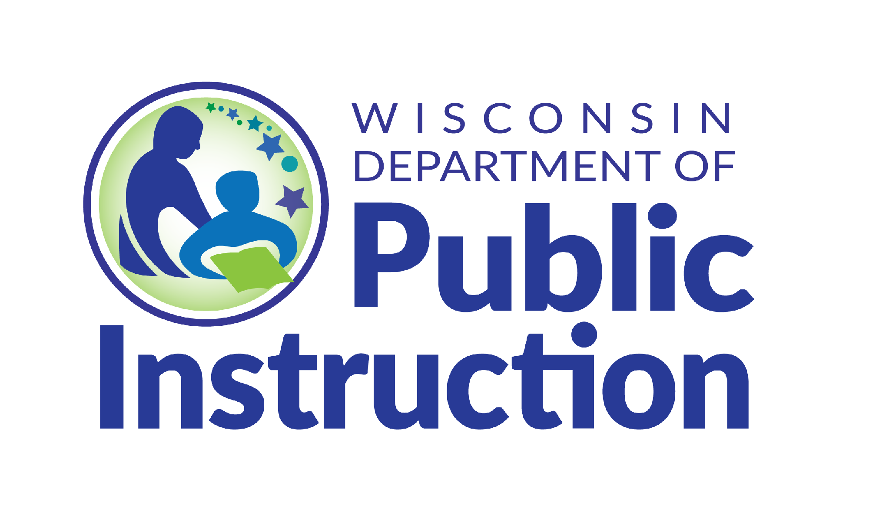

Building The Foundation

Mission, Purpose, Vision

Every successful CCoT Team begins with a shared understanding of where the team is headed, why the team exists, and how the team will work together. A clear vision, purpose, and mission help guide conversations, decisions, and actions.
Think of these statements as a pathway:
Vision - Purpose - Mission - Action
Statement | Question It Answers | Definition & Focus
Vision | Where is the CCoT Team going? | Describes the future the CCoT Team hopes to create. A shared picture of what is possible.
Purpose | Why does our CCoT Team exist? | Explains the reason the team comes together and the difference it hopes to make.
Mission | What will our CCoT Team do? | Describes the work the team will complete to move toward the vision.
These statements do not have to be perfect. They should reflect the shared thinking of the team and can be revisited as the team grows, learns, and responds to changing community needs.
CCoT Facilitator Reflection & Notes
Where is the CCoT Team Today?
• Do team members have a shared understanding of why the team exists?
• Can members describe what success looks like for youth in the community?
• Are the team's activities connected to a common goal?
• Which of our current statements still feel meaningful?
• Which statements no longer reflect who we are or where we are headed?
[Enter Facilitator Reflection & Notes here]
Vision Statement Planning
Example: "All students with disabilities have opportunities, connections, and support to achieve their goals for life after high school."
Draft Team Vision Statement:
[Enter Vision Statement here]
Purpose Statement Planning
Example: "The CCoT Team brings together community partners to identify and address barriers that impact successful transitions for students."
Draft Team Purpose Statement:
[Enter Purpose Statement here]
Mission Statement Planning
Example: "The CCoT Team collaborates with schools, agencies, businesses, families, and youth to create pathways and opportunities that support successful transitions to adult life."
Draft Team Mission Statement:
[Enter Mission Statement here]
From Statements to Action
1. What are our top three priorities this year?
[List top 3 priorities]
2. How do these priorities connect to our mission?
[Describe connection]
3. How will we know we are making progress?
[Identify progress indicators]

The Transition Improvement Grant (TIG) (CFDA# 84.027A) acknowledges the support of the Wisconsin Department of Public Instruction in the development of this material and for the continued support of this federally funded grant program. There are no copyright restrictions on this document; however, please credit the Wisconsin DPI and support of federal funds when copying all or part of this material.

