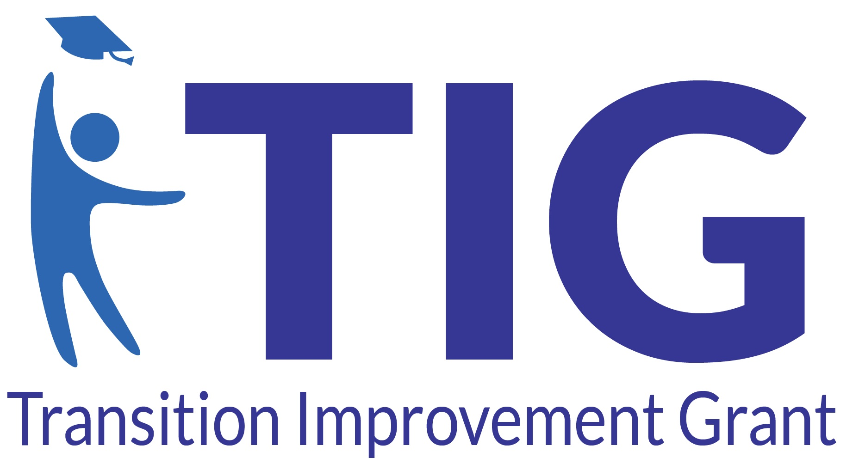

County Community on Transition (CCoT) Team Agenda

Date & Time: | Wednesday, October 14, 2026 | 1:00 PM – 2:30 PM EST (90 Mins)
Location / Link: | County Educational Service Agency (CESA) Boardroom & Zoom
Attendees:

1. Co-Created Partner Inputs (Pre-Meeting Pulse Survey & Subcommittee Feedback)
Inputs Gathered 7 Days Prior to Meeting:
• DVR Representative: Highlighted a gap in student intake referrals prior to age 18; requested discussion on streamlining referrals.
• Employment Subcommittee: Submitted a proposal for the Spring Business Engagement Luncheon needing team approval.
• Transition Coordinators: Requested quick update on Indicator 14 data.

2. Purpose-Driven Transition Agenda
Time & Duration | Topic & Lead Partner | Classification | Stated Purpose & Desired Outcome | Required Prep
1:00 - 1:10 PM  (10 mins) | Welcome & Partner Introductions  (Lead: CCOT Chair) | INFORMATION | Review partner survey input, align on agenda, and welcome new ADRC liaison. | Review survey summary
1:10 - 1:25 PM  (15 mins) | Indicator 14 Data Review  (Lead: District Coordinators) | INFORMATION | Present most recent county-wide data | Read Indicator 14 Data One-Pager
1:25 - 1:55 PM  (30 mins) | DVR Referral & School Workflow  (Lead: DVR & School Leads) | DISCUSSION | Evaluate current intake barriers and map out a standardized multi-district referral procedure for students at age 16-18.
1:55 - 2:20 PM  (25 mins) | Spring Transition Fair & Employer Luncheon  (Lead: Employment Subcomm.) | DECISION / ACTION | Vote on date, venue, budget needs, and assign subcommittee lead roles. | Review Event Proposal
2:20 - 2:30 PM  (10 mins) | Partner Announcements & Next Steps  (Lead: All Partners) | DECISION / ACTION | Share any updates/events, confirm commitments, set next meeting date, and conduct 2-min feedback survey | Bring agency event dates

3. To-Dos
Action Item / Decision Description | Assigned Partner / Agency | Target Date | Status
Draft revised one-page DVR referral checklist for high school special ed teachers. | DVR Liaison | Nov 01, 2026 | In Progress
Secure venue for Spring Employer Luncheon at Tech College. | Employment Subcomm. | Oct 28, 2026 | Pending Vote
Distribute finalized meetings notes (along with Big Picture to share with team/supervisor) to CCOT listserv. | CCOT Notetaker & Facilitator | Oct 20, 2026 | Scheduled

The Transition Improvement Grant (TIG) (CFDA# 84.027A) acknowledges the support of the Wisconsin Department of Public Instruction in the development of this material and for the continued support of this federally funded grant program. There are no copyright restrictions on this document; however, please credit the Wisconsin DPI and support of federal funds when copying all or part of this material.

